LAB 4

Student Name | Athira J
Roll No. | 2401201018
Course / Semester | BCA / 5th
Subject | Design and Analysis of Algorithms

1. Aim
To implement three Dynamic Programming algorithms—Longest Common Subsequence (LCS), 0/1 Knapsack, and Matrix Chain Multiplication—and study their DP tables, optimal results, time and space complexity, execution performance, and visual representations.

2. Objectives
- Set up a Python workspace and import the required libraries.
- Implement LCS to identify the longest common subsequence of two strings.
- Implement 0/1 Knapsack to select items that maximize profit within a capacity.
- Implement Matrix Chain Multiplication to find the minimum scalar multiplication cost.
- Measure execution time, memory usage, and the number of DP subproblems.
- Visualize DP tables and compare algorithm performance.

3. Software and Libraries Used
Python 3.14.6, Jupyter Notebook, NumPy 2.4.6, Matplotlib 3.11.0, and Python standard libraries: os, sys, time, and tracemalloc.

4. Introduction to Dynamic Programming
Dynamic Programming (DP) is an algorithm design technique used to solve problems that have overlapping subproblems and optimal substructure. It stores the results of smaller subproblems in a table so that the same work does not need to be repeated. This report uses bottom-up tabulation to solve sequence analysis, resource allocation, and matrix computation optimization problems.

5. Algorithm Implementations and Results

5.1 Question 1 – Project Setup
A project workspace named Lab4_Smart_Optimization was created. Separate screenshots and reports folders were prepared. The required Python libraries were imported successfully. The captured environment reported Python 3.14.6, NumPy 2.4.6, and Matplotlib 3.11.0.

5.2 Question 2 – Sequence Analysis using LCS
The LCS algorithm builds a two-dimensional DP table for the prefixes of two input strings. If the current characters match, the diagonal value is increased by one; otherwise, the maximum of the top and left cells is selected. Backtracking through the table reconstructs an LCS.
Input strings: X = AGGTAB and Y = GXTXAYB.
Observed result: Longest Common Subsequence = GTAB; length = 4.
Time complexity: O(m × n). Space complexity: O(m × n).

5.3 Question 3 – Resource Allocation using 0/1 Knapsack
The 0/1 Knapsack algorithm considers each item and each capacity. For every state, it compares excluding the current item with including it when its weight fits. Backtracking identifies the selected items.
Input weights = [2, 3, 4, 5], profits = [3, 4, 5, 6], capacity = 5.
Observed result: Selected items = [1, 2]; maximum profit = 7.
Time complexity: O(n × W). Space complexity: O(n × W).

5.4 Question 4 – Matrix Chain Multiplication
Matrix Chain Multiplication determines the order in which a chain of matrices should be multiplied to minimize scalar multiplication cost. The cost table stores the minimum cost for each matrix interval, while the split table records the optimal partition point.
Input dimensions: [10, 30, 5, 60].
Observed result: Optimal order = ((A1 × A2) × A3); minimum cost = 4500.
Time complexity: O(n³). Space complexity: O(n²).

6. Complexity Comparison of Dynamic Programming Algorithms
The following table summarizes the theoretical time and auxiliary space complexities of the three implemented algorithms.
Algorithm | Time Complexity | Space Complexity | DP States
Longest Common Subsequence | O(m × n) | O(m × n) | (m + 1)(n + 1)
0/1 Knapsack | O(n × W) | O(n × W) | (n + 1)(W + 1)
Matrix Chain Multiplication | O(n³) | O(n²) | n(n + 1) / 2 intervals
Here, m and n denote the lengths of the two LCS strings; n is the number of items and W is the knapsack capacity; and n is the number of matrices in Matrix Chain Multiplication.

7. Question 5 – Performance Analysis
Execution time was measured using time.perf_counter(). Peak traced Python memory was measured using tracemalloc and converted into KB. The number of subproblems was calculated from the dimensions of each DP table or interval set.
Algorithm | Execution Time (ms) | Memory (KB) | Subproblems
LCS | 0.1380 | 0.58 | 56
0/1 Knapsack | 0.0779 | 0.46 | 30
Matrix Chain | 0.1408 | 0.92 | 6
The values above are the measurements visible in the supplied notebook screenshot. Execution time and traced memory are environment-dependent and may vary between runs. The memory figure represents Python-tracked peak allocations during the measured function, not total process RAM.

8. Question 6 – Visualizations
Matplotlib was used to create heatmaps for the LCS, Knapsack, and Matrix Chain DP tables. Bar charts compare execution time, memory usage, and the number of subproblems solved. The heatmaps use color intensity to represent stored DP values, while the bar charts make differences between the algorithms easier to observe.

LCS DP Table
The heatmap displays the LCS length stored at each prefix pair.

0/1 Knapsack DP Table
The heatmap displays the best profit for each item-prefix and capacity.

Matrix Chain Cost Table
The heatmap displays the minimum multiplication cost for matrix intervals.

Execution Time Comparison
The chart compares measured execution time in milliseconds.

Memory Usage Comparison
The chart compares peak traced memory in KB.

Subproblems Solved Comparison
The chart compares the number of DP states or intervals counted.

9. Observations
- LCS produced the subsequence GTAB with a length of 4 for the supplied strings.
- The Knapsack solution selected items 1 and 2, reaching a total profit of 7 within capacity 5.
- Matrix Chain Multiplication found the order ((A1 × A2) × A3) with a minimum cost of 4500.
- The measured Knapsack execution time was the lowest in the captured run; measured Matrix Chain memory was the highest.
- The number of stored DP states depends on the input dimensions. A smaller state count does not necessarily imply lower execution time because the work performed per state differs.
- DP avoids repeated recursive work by storing intermediate results, trading additional table memory for improved computational efficiency.

10. Conclusion
The lab successfully implemented three classical Dynamic Programming algorithms: LCS, 0/1 Knapsack, and Matrix Chain Multiplication. Their DP tables were constructed and used to recover optimal solutions. Execution time, peak traced memory, and subproblem counts were measured, and visualizations were generated to support performance comparison. The experiment demonstrates how Dynamic Programming uses overlapping subproblems and stored results to solve optimization problems efficiently.

Appendix A – Notebook Screenshots and Outputs
The following screenshots are included in the same order in which they were supplied. They document the project setup, algorithm code, outputs, performance analysis, and generated visualizations.
Question 1 – Project setup and imported libraries
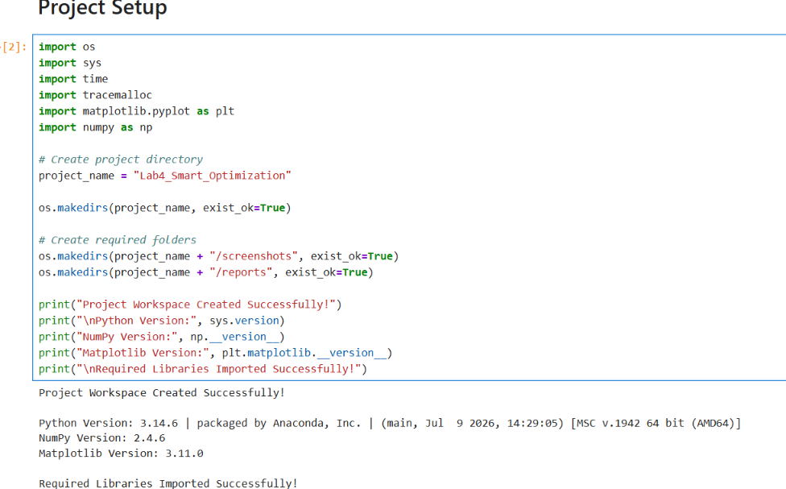

Question 2 – LCS function implementation
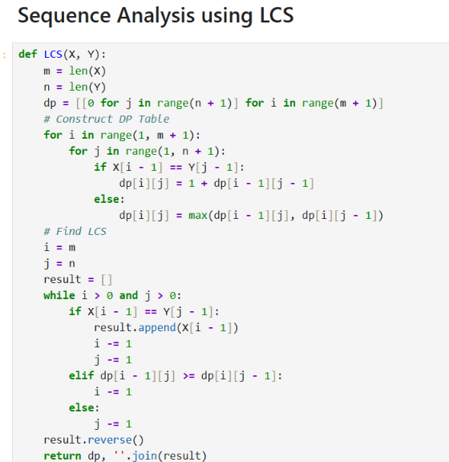

Question 2 – LCS input, DP table, and result
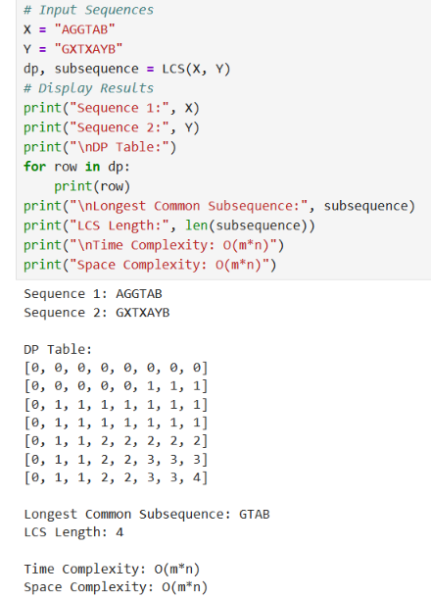

Question 3 – 0/1 Knapsack function implementation
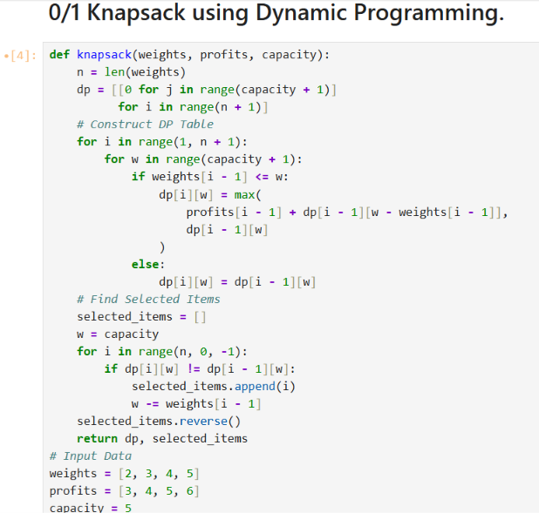

Question 3 – Knapsack DP table and selected items
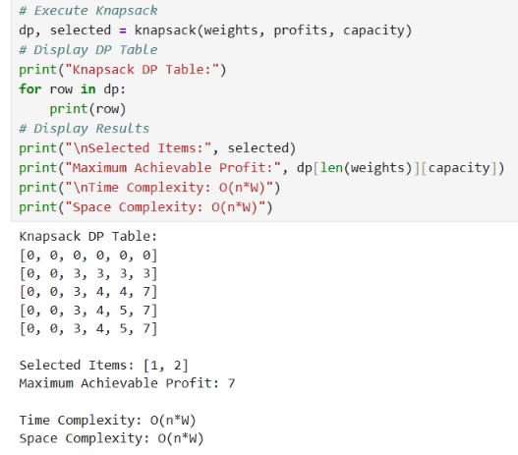

Question 4 – Matrix Chain Multiplication function
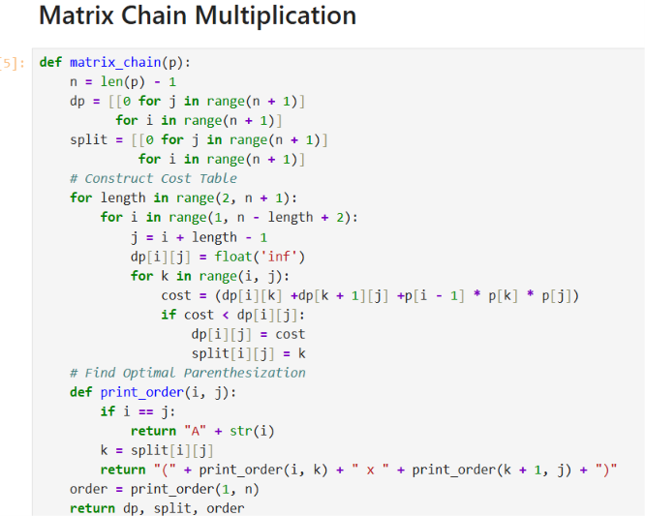

Question 4 – Cost table, split table, and optimal order
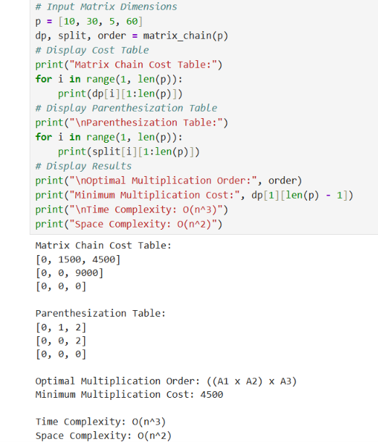

Question 5 – Performance measurement function and algorithm calls
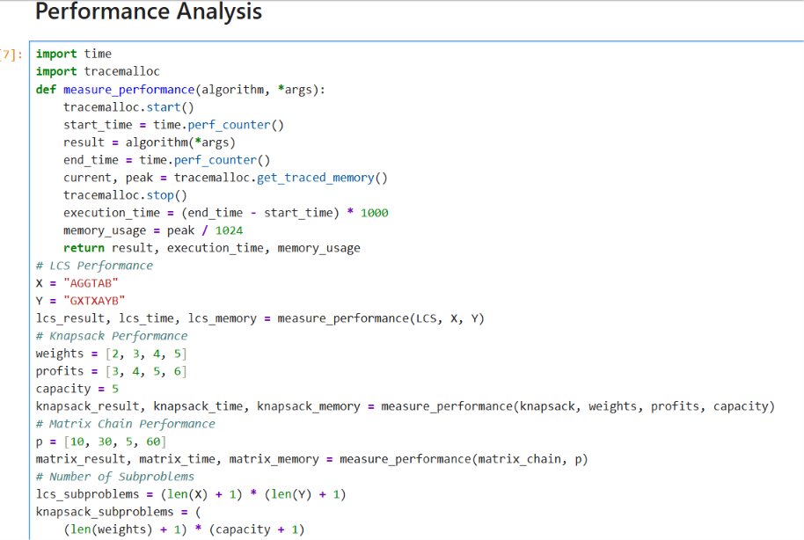

Question 5 – Performance and complexity comparison output
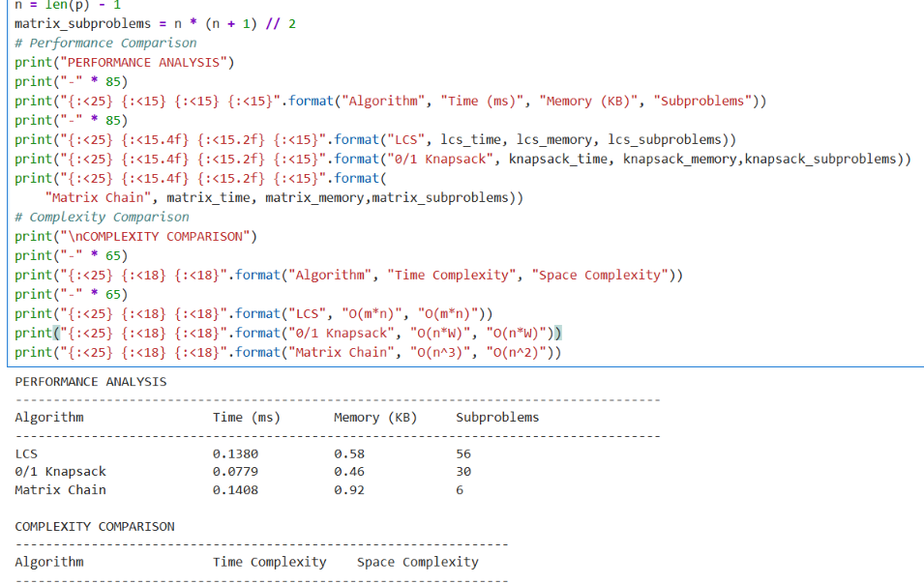

Question 6 – Visualization code: LCS DP table
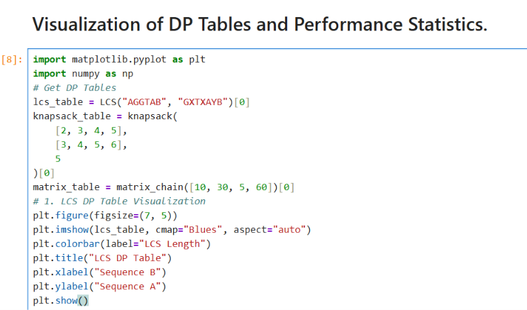

Question 6 – LCS DP table heatmap
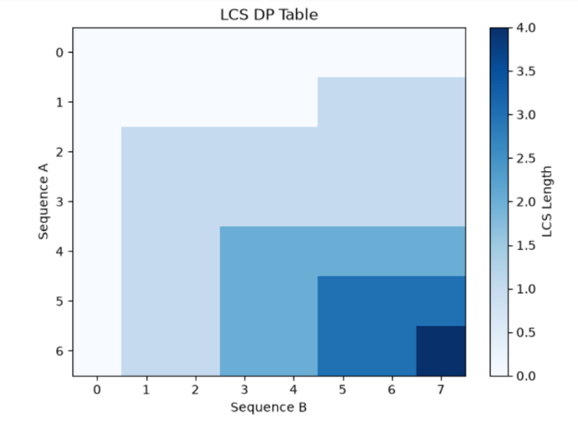

Question 6 – Knapsack DP table visualization code
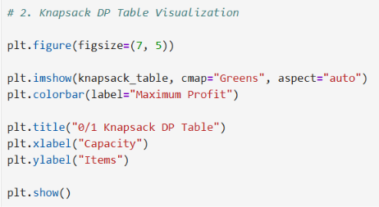

Question 6 – Knapsack DP table heatmap
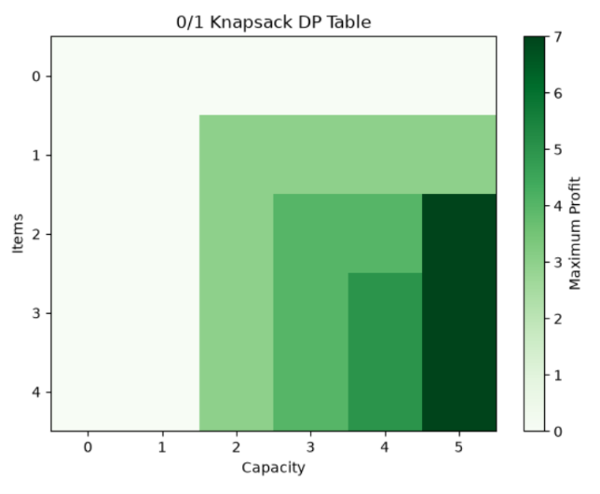

Question 6 – Matrix Chain cost table visualization code
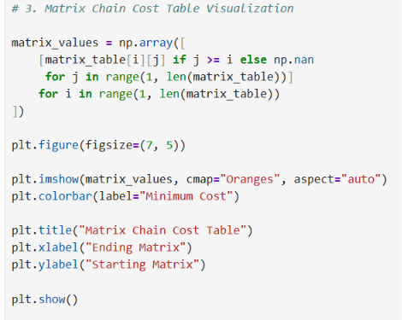

Question 6 – Matrix Chain cost table heatmap
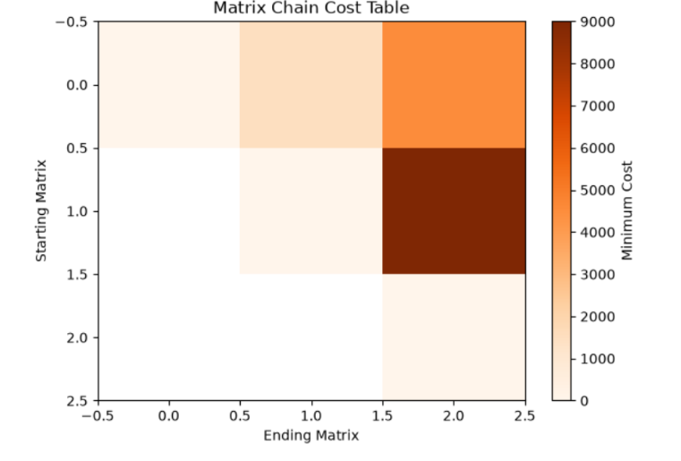

Question 6 – Execution time comparison code
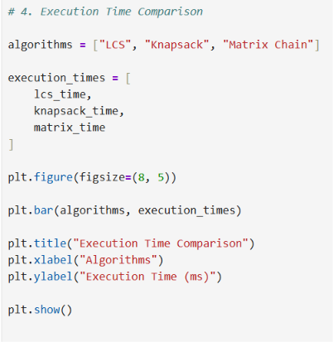

Question 6 – Execution time comparison chart
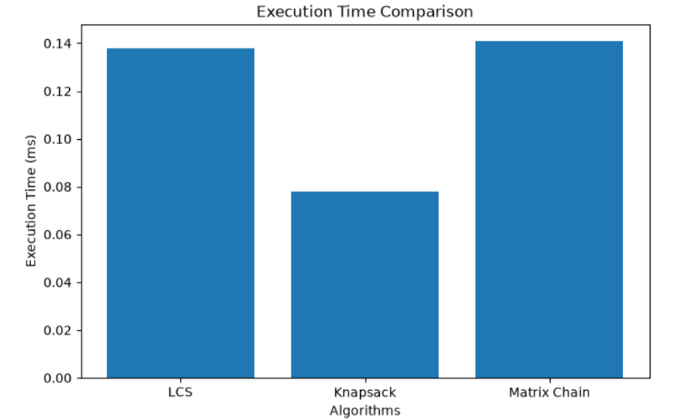

Question 6 – Memory usage comparison code
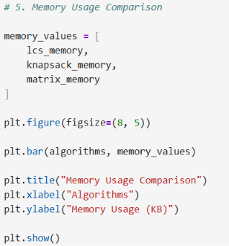

Question 6 – Memory usage comparison chart
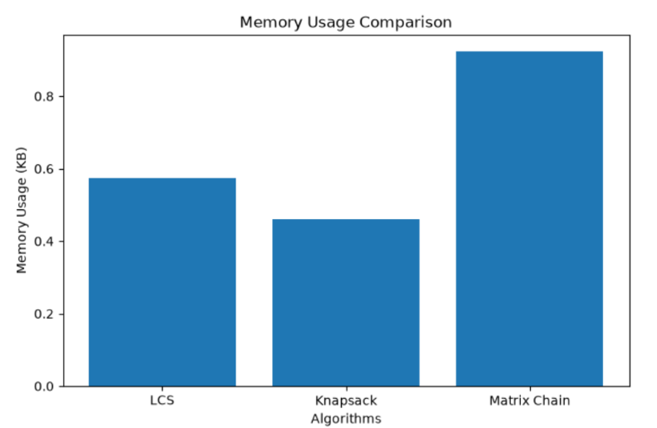

Question 6 – Subproblems comparison code
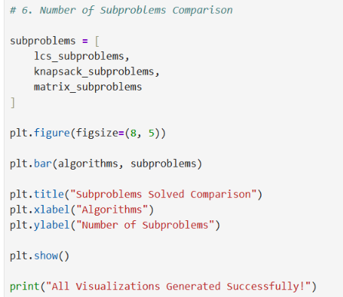

Question 6 – Subproblems solved comparison chart
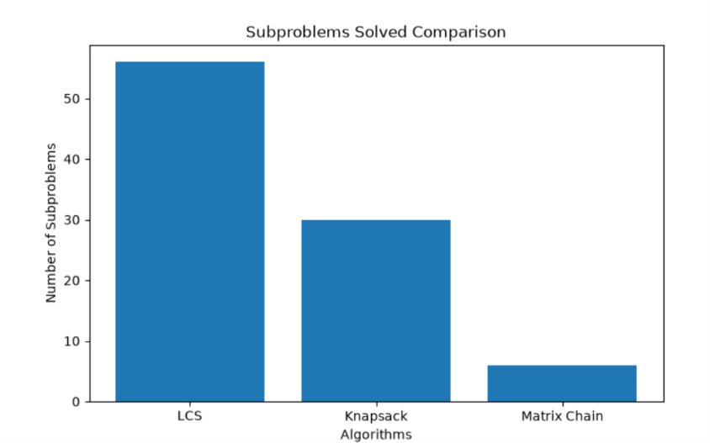

https://github.com/AthiraJoy555/DAA_Lab_4

